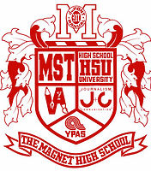

**duPont Manual High School**

**Class of 2023!**

**CALENDAR OF EVENTS**

**MATH, LITERACY & SPANISH PLACEMENT EXAMS:**

MST – Tuesday, April 23, 2019 – 3:15 – 5:30 PM

HSU – Wednesday, April 24, 2019 – 3:15 – 5:30 PM

J&C/VA/YPAS – Thursday, April 25, 2019 – 3:15 – 5:30 PM

*Please make plans to have students picked up promptly at 5:00 PM, or 5:30 PM if they plan to take the Spanish exam.

**Athletic Open House**: May 15, 2019 – 6:00 – 7:00 PM

**FRESHMAN SUMMER REGISTRATIOIN:** August 6, 2019

Additional information will be coming in the mail this summer.

**CRIMSON DAY:** August 9, 2019

**FIRST DAY OF SCHOOL:** August 14, 2019

Welcome to Manual High School. We are so proud of your accomplishments thus far and look forward to celebrating the many milestones to come. In order to prepare for your freshman year there are several items that need to be addressed.

PARENT PORTAL:

Log onto: [www.jcpsky.net](http://www.jcpsky.net)

Click on: Parents

Click on: Parent Portal

Follow account set-up instructions

Check email

HIGH SCHOOL PERMANENT RECORD:

* Copy of certified birth certificate.
* Copy of social security card (used to coordinate KEES scholarship money.
* Copy of current Kentucky immunization certificate with expiration date. Certificate must include HepA and Meningococcal vaccines.
* Your student’s records will be requested from their Middle School. However, the documents listed above are not included with private, parochial or out of state records.
* All incoming students enrolling at Manual from a private, parochial or out of state school will need to provide these documents to the Manual Guidance Office.
* Anita Sanders, Records Clerk/Registrar (502) 485-8503. Records can also be uploaded and emailed to the following email address: [anita.sanders@jefferson.kyschools.us](mailto:Anita.sanders@jefferson.kyschools.us).

**Counselors:**

Marti Johnston

[marti.johnston@jefferson.kyschools.us](mailto:marti.johnston@jefferson.kyschools.us)

Michelle Leslie

[michelle.leslie@jefferson.kyschools.us](mailto:michelle.leslie@jefferson.kyschools.us)

Amy Meeron

[amy.meeron@jefferson.kyschools.us](mailto:amy.meeron@jefferson.kyschools.us)

Amy Medley

[amy.medley@jefferson.kyschools.us](mailto:amy.medley@jefferson.kyschools.us)

Kevin Fowler – all YPAS

[kevin.fowler@Jefferson.kyschools.us](mailto:kevin.fowler@Jefferson.kyschools.us)

Counseling Website:

[www.dupontmanual.com/counseling](http://www.dupontmanual.com/counseling)

Counseling Twitter:

@dmhsguidance

Manual Athletics:

@ManualAthletics

duPont Manual Website:

[www.dupontmanual.com](http://www.dupontmanual.com)

duPont Manual Twitter:

@duPontManual

Subscribe to Manual POST

e-newsletter:

Bit.ly/POSTSubscribe

J&C News:

Manualredeye.com

Contact the PTSA:

[Manualptsa@gmail.com](mailto:Manualptsa@gmail.com)

Manual PTSA:

@manualptsa

facebook.com/groups/ManualPTSA

**CHOOSING A FOREIGN LANGUAGE AND THE APPROPRIATE LEVEL OF DIFFICULTY**

Any student wishing to take beyond Honors Level I Spanish should plan to take the Spanish placement exam immediately following the student’s math and literacy placement exam.

* Manual offers 4 years of instruction in French, German, Latin, and Spanish.
* In addition, AP classes are offered in French, Latin, and Spanish, as well as courses in Spanish Humanities and Spanish Conversation.
* **ADVANCED:** Student prefers an accelerated pace.
* **HONORS:** Honors level classes teach the basic language skills at a slightly slower pace, allowing more time for practice and reinforcement of concepts.
* **FRENCH**: Students who have had 2 or more years of French in middle school may enroll in Adv. French 2 with the recommendation of their middle school French teacher.
* **SPANISH**: Students who have had one full year or more of Spanish will need to take a placement test to determine their level. The test will be administered on the same day as the math placement test.
* **GERMAN:** Freshmen choosing these languages need to enroll in level 1, either advanced or honors.
* **LATIN:** Advanced is the only level offered.

**ENGLISH CLASS**

Summer Reading Suggestion: (From 9th Grade English Teachers)

For recommended reading, rising freshmen intending to take Advanced English may want to read some Greek mythology. It creates a little context for The Odyssey.

Note: If you want to be considered for the AP Seminar (English 2) course during your sophomore year – you must take Advance Program (ADV) English 1 as a prerequisite.

**VA REMINDER:**

By 2nd week of school:

• 1 Masonite drawing board, at least 22”x25”

• 1 red fiber portfolio, at least 20”x26”

• 1 plastic art bin tool box to carry supplies—12 or 14”x6” to 8”x6”to 8” (can be a tackle box)

**MANUAL PTSA INFORMATION**

Congratulations on your child’s acceptance into Manual! As you will soon see, Manual PTSA offers a multitude of wonderful events and programs throughout the school year that benefit your child, teachers, parents, and the community. We help host College 101 night, support a fun-filled Red/White spirit week, email a weekly newsletter, sell spirit wear, host a silent auction, help throw a huge graduation party for the seniors, and much more. Please consider lending your time to a fabulous organization that touches the lives of your students each and every day. We advocate, inform, and involve. With your help, we can present programs throughout the year to support all students and teachers.  To connect with current Manual parents, get school news, &/or volunteer for next year's PTSA Board, email manualptsa@gmail.com. We look forward to meeting you during registration week!

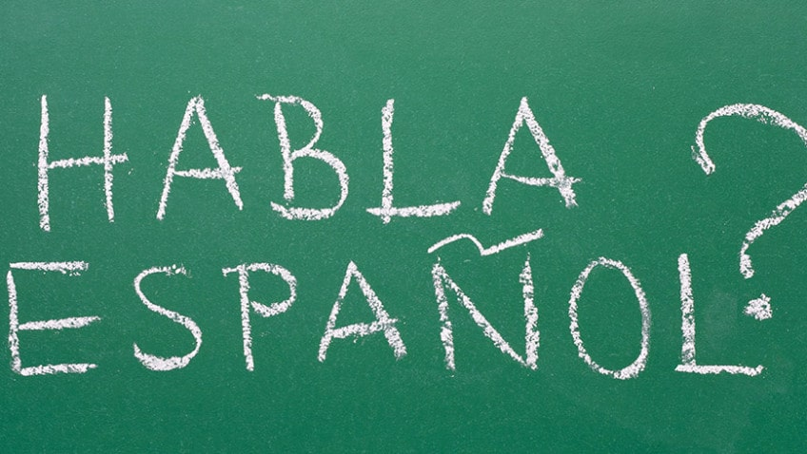

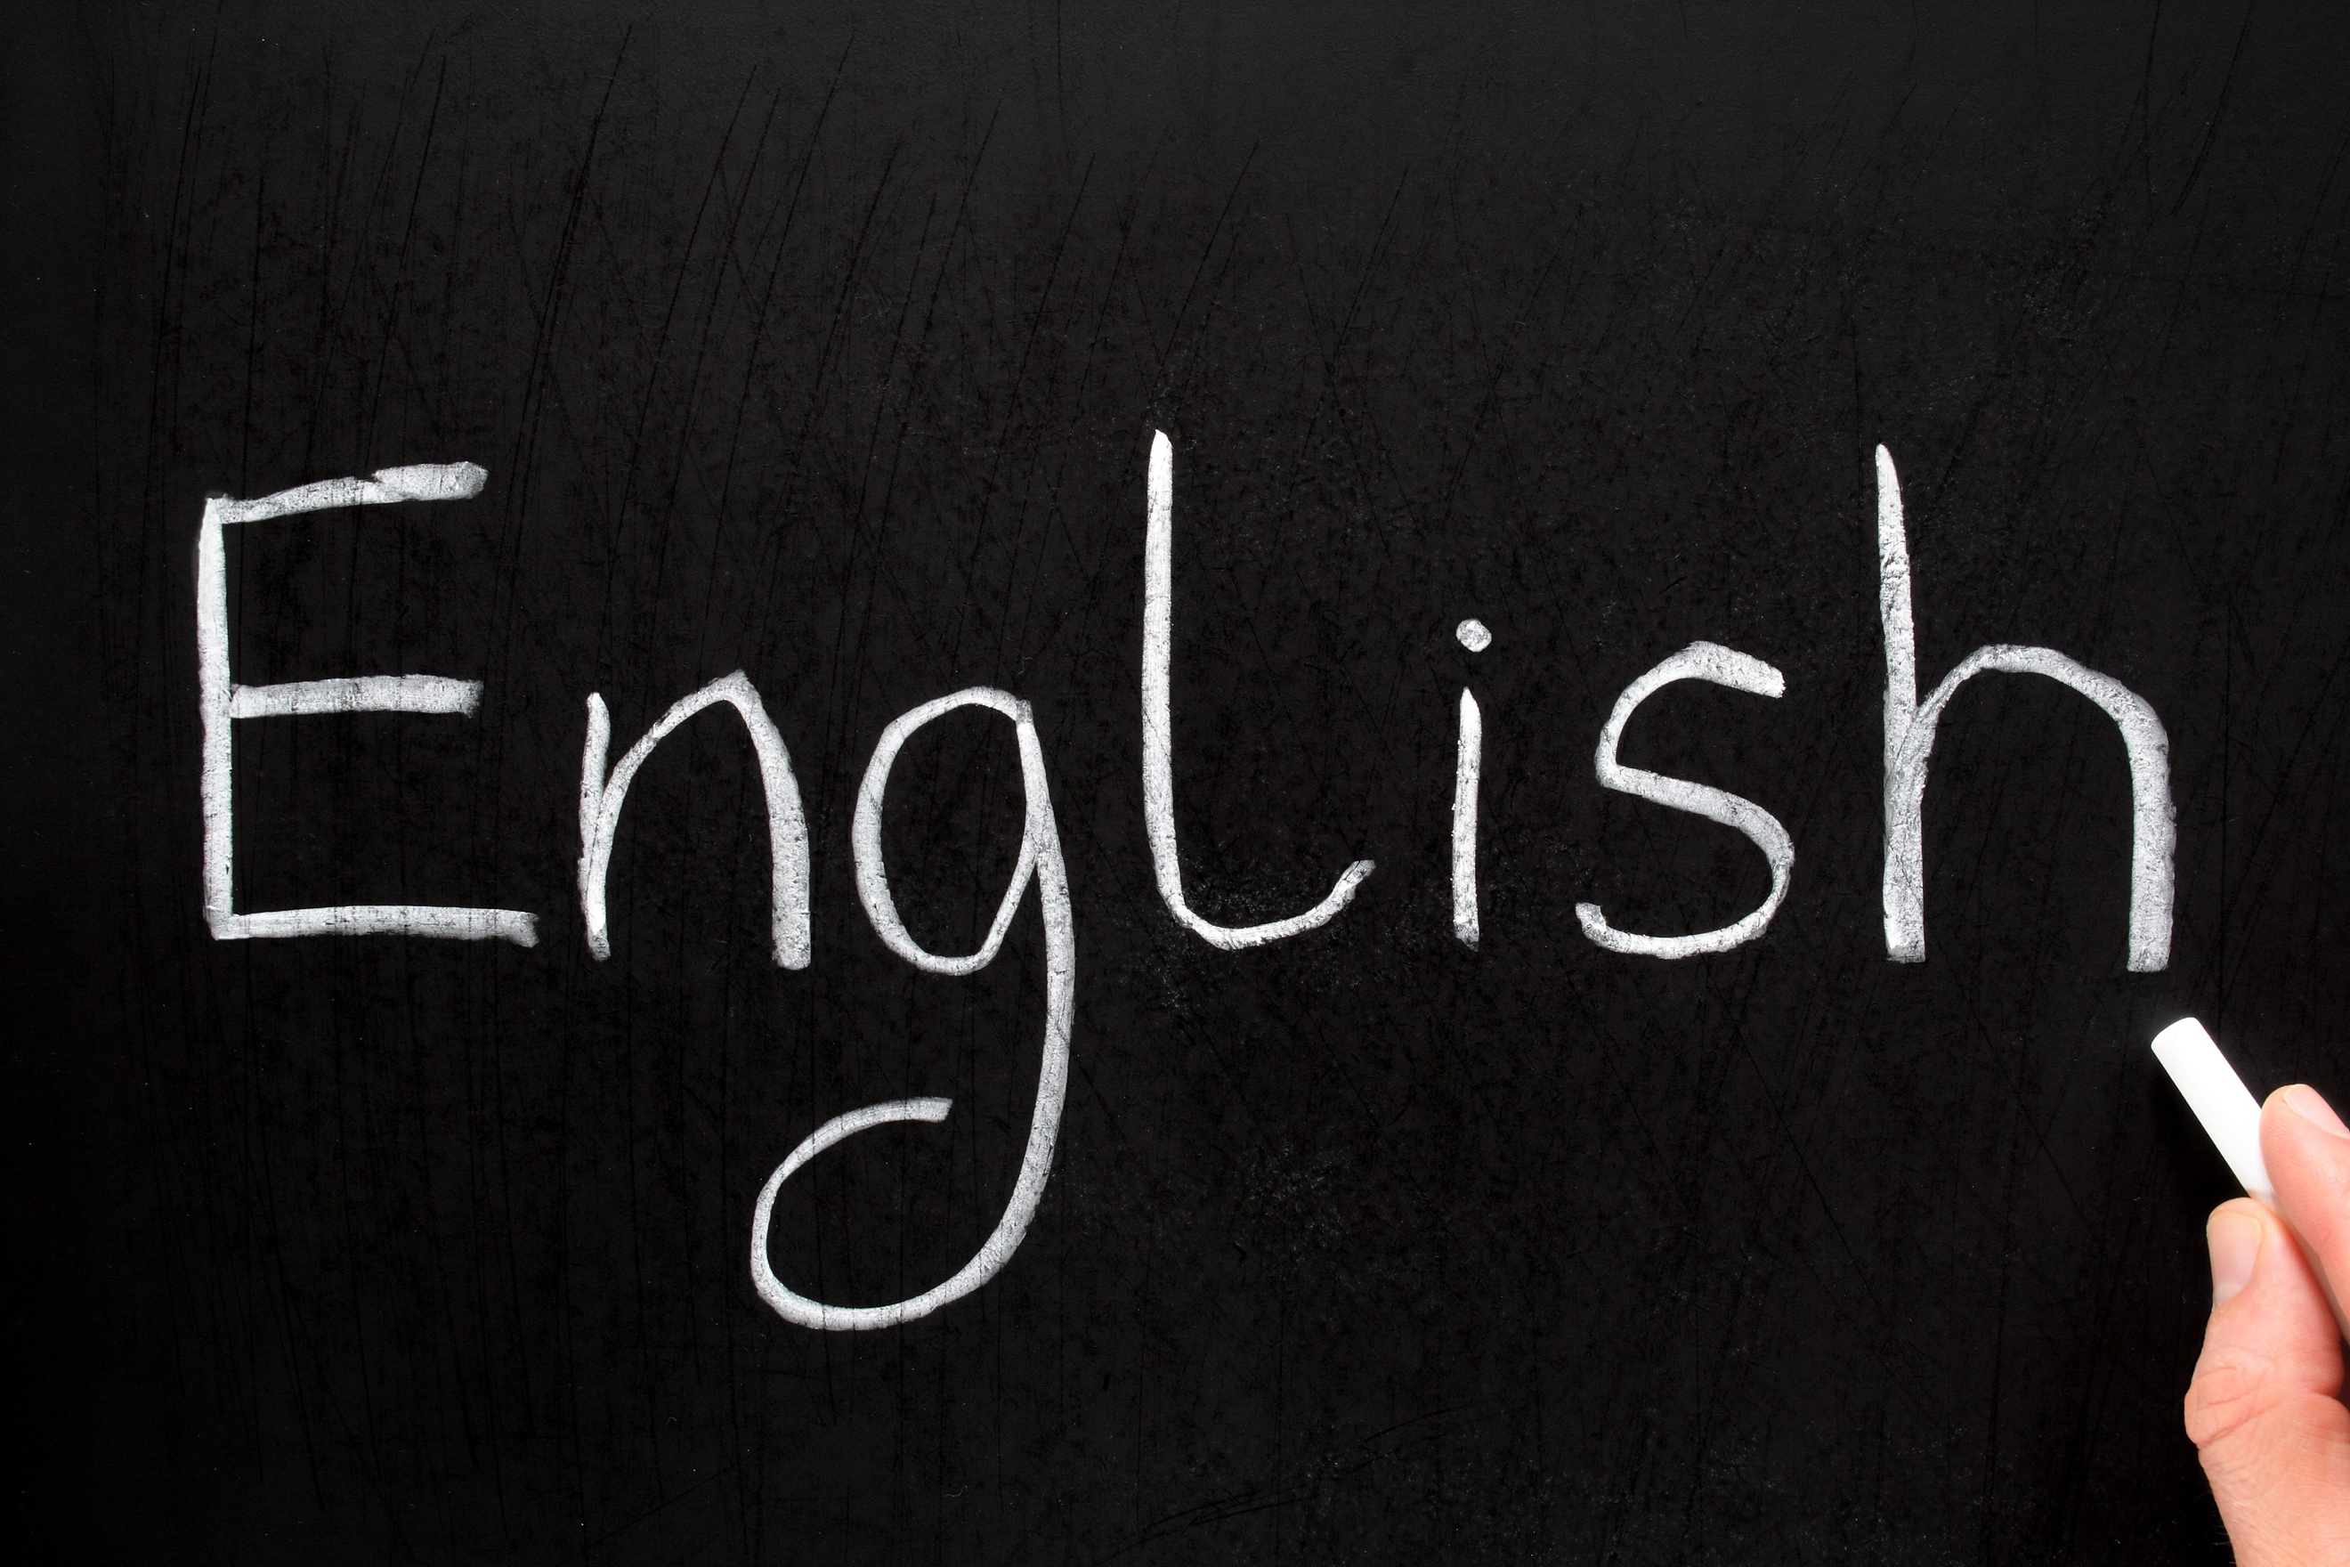



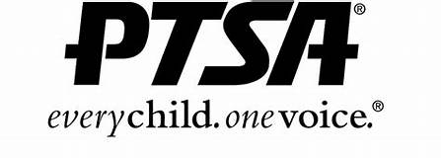

**FRESHMAN ELECTIVES**

Study Skills: Study hall time for students to work on homework, receive peer tutoring, or work with a teacher.

Visual Art: This course is the foundation course in art for the high school student. In the course, the student receives instruction in the studio areas—design, drawing, painting, printmaking, ceramics, sculpture, and textiles—that increase basic art skills developed in the middle school art program.

FACS (Life Skills): FACS Essentials introduces students to basic life skills including units on college and career planning, personal finance, food preparation, nutrition basics, clothing care, and risky behavior. This is the course everyone says should still be taught in all schools as Adulting 101.

Fashion & Interior Design 1: Fashion Design I class provides opportunities for students to develop career competencies in the fashion and/or interiors industry by applying information related to social, economic, and media influences. Students apply knowledge of design principles and processes through skill performance activities, such as sewing.

Principles of Hospitality: This course is designed for students interested in marketing careers in the hospitality industry. The instruction includes career awareness in the areas of recreation, travel/tourism, hotel/motel, and restaurant. This course is based on the business and marketing core that includes communication skills, economics, operations, promotion, selling, and product/service management.

Web Page Development: Web Page Design using HTML will be introduced. Creating web documents using a simple text editor will be the main focus. How to use a simple web editor will also be covered. Features such as layout, tables, images, forms, frames and the incorporation of sound and video will be explored. Developing site specifications and methods to increase the appeal and effectiveness of web sites are included.

Engineering Design: A project and research based course that extends the learning experiences where students focus on mechanical, electrical, fluid and thermal systems allowing in depth exploration in selected disciplines of engineering areas such as manufacturing, power/energy/transportation, bio-medical, robotics, hydraulics, electricity/electronics, communications, construction systems, alternative energy, computer aided design and problem solving.

Sociology: Sociology is the scientific study of human society. It is concerned with the behavior of human beings in group situations. The study of sociology, therefore, consists of trying to understand: The basic units and institutions of social life, such as the family, schools, neighborhoods, rural and urban communities, and the many other kinds of groups with which humans identify. This group can include occupational, political, religious, ethnic, family, economic status, or ideology. The sociological perspectives focus on how those social relationships arise, why they persist, why antagonisms develop, and how they maintain social order to contribute to social change.

Fundamentals of Dance: This course instructs students in basic dance movement skills to increase body awareness, enhance self-image, improve physical fitness and develop personal expression potential. Students will learn fundamental techniques in 6 week periods of study in Yoga, Ballroom and Folk, modern dance/dance history, Aerobics and Conditioning, African dance and culture, Jazz, dance composition and improvisation.

Exploring Theatre: This course is an introductory course designed to increase students' understanding, appreciation, and critical perceptions of the theatre. Course content is based on the idea that a love for and knowledge of the theatre--whether as an active participant, a reader of good plays, or simply as a member of a theatre audience--is a significant means of enriching an individual’s life.

Marching Band: Marching/Pep Band I, II, III, IV are a fifth period course offered to students who want to participate in a non-competitive marching band that meets after school two days a week immediately after school. Although, the band is non-competitive, there will be opportunities to perform in exhibition in competitions throughout Kentucky and Indiana.

# **What to Expect Your Freshman Year of High School**

## Anticipate Higher Expectations:

## One of the ways in which high school differs from middle school the most is the higher expectations. You’ll find that you’re expected to keep closer track of your own schedule and responsibilities, along with your classes becoming more challenging. One way to prepare in advance for these higher expectations across the board is to ensure that you have a solid organization system in place before you start high school. Get familiar with using your school agenda/planner to keep track of your own assignments and commitments.

## Learn Self Advocacy:

## Another critical skill for meeting these higher expectations is building a strong support network. No matter how strong a student you are, at some point you’re bound to need some help. Maintaining healthy relationships with your peers, mentors, and teachers is a great way to make sure that you have people who are willing to help when you need them. Be an engaged learner during class and stay after class to ask questions. Utilize email or class messaging systems. Always ask for help when you need it. Don’t wait until you’re drowning in work and commitments to admit that you need a hand. Instead, lean on your support system to help keep you afloat while you’re getting it all figured out.

Reinvent Yourself:

This is your chance! Remember the nickname you thought was so cool in fifth grade? Or that role you took on in a club/organization that you didn’t really like but it somehow followed you for three full years? We have some great news for you. High school is a great opportunity to reinvent yourself. Before you start ninth grade, think about who you really want to be and what you really want to be known for. Will you be a student who goes to study sessions and stays late to meet with teachers when he or she needs extra help? Will you volunteer to help when no one else does? Think about it—who do you really want to be? This is your shot.

Start Thinking About College:

While it seems early, and in a lot of ways, it is early, freshman year is a great time to start wrapping your head around your education after high school. You can start by keeping a casual college list and researching what kinds of grades and other attributes are necessary to get into the kinds of schools you’re interested in attending. Now is also the time to crack down on academics so that your grades will be up to snuff. Remember that colleges can and do review your grades from all four years of high school. While some stumbling points during freshman or sophomore year can be overcome, your best bet is to maintain strong grades throughout all four years of high school.

Source: <https://blog.collegevine.com/>